April assessment presentation: Reading
Due: Monday 29th April 2019

Well done Grade 3 for your insightful presentations last month! This month, we are going to use our knowledge of non-fiction text and biography from our Reading lessons to make an exciting, insightful presentation.
This Month, we are going to be asking you to create a keynote presentation on a figure from a biographical book. Please do not choose the same person as any of your previous presentations!

Remember: We are looking for engaging presentations that have been well researched and address the criteria below as well as the generic presentation guidelines used previously that have been posted on Weebly in the homework section.

You MUST NOT plagiarise by copying and pasting from the internet – this will result in a failed assessment.

You could base your presentations on one of the following biography books we have in class or a biography from home (please ask if you’re unsure):
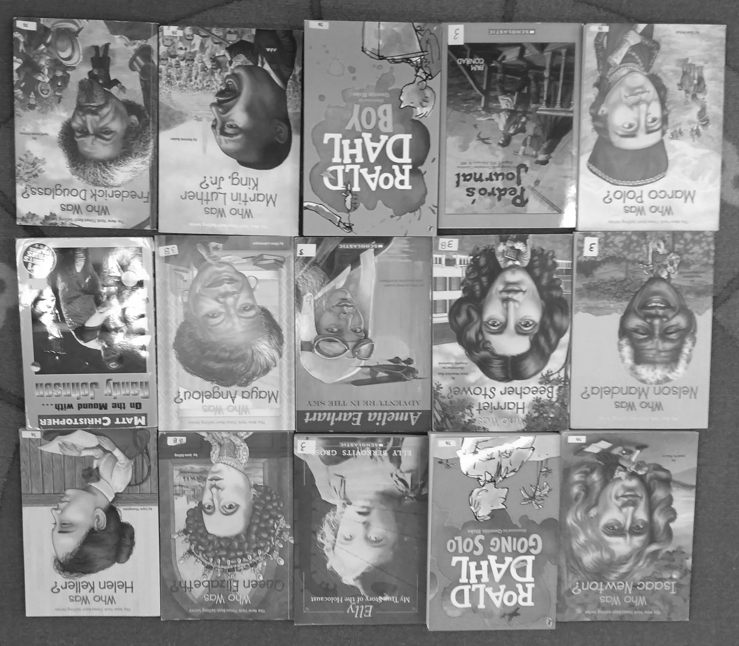

In your presentation, you need to include the following points (don’t forget to expand on these points!):
- Who are you doing your presentation on?
- Why did you choose this biography?
- What was he/she famous for?
- What struggles did he/she face or go through?
- How did he/she overcome their struggles?
- How can we learn from this person and how can we apply it to our lives today?
- How has this person influenced you?

Your presentation should be in keynote format and be between 5 – 10 minutes long. Please practice and rehearse your presentation to be confident and know how long it will take you. Also think of questions the audience may ask so you’re well prepared!

Hint: Be cautious of the overuse of transitions!

